Covid-19 Statement

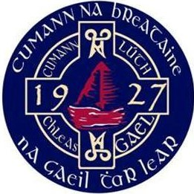

26th. March 2020.

Further to our Statement 12th. March 2020, updates announced by Government, the latest GAA Croke Park Statement, The Provincial Council of Britain Gaelic Athletic Association have decided to continue the suspension of all activity at Club, Inter-County and Educational levels until Sunday 19th. April 2020 (inclusive) at which stage arrangements will be reviewed.
This is to include all games, training and team or members gatherings at all ages and all grades. Club facilities must remain closed, Clubs are also advised to refrain from undertaking new capital projects while support funding for this type of work is suspended as is PIS cover. We will continue to liaise with Croke Park, heed Government advice and review the situation. In the meantime, please stay safe, look out for one another and continue to follow the guidelines which have been provided by NHS England, Scotland & Wales. Further updates will be published via County Secretaries and the Councils Website.

A Separate Statement will be issued to the Council’s Employees.

www.britain.gaa.ie

The Provincial Council of Britain GAA, 20 – 22 Wenlock Road, London, N1 7GU

